EQ: How do people respond to humor and why do responses vary?

Primary Text Examples
“Who’s on First”? Abbott and Costello (I included it even though it’s more than one page because it is so classic.) Here’s the link:

SNL Kim Kardashian, Kanye West, and Trayvon Martin
Was it appropriate or not?
http://theclicker.today.msnbc.msn.com/_news/2012/04/15/11209979-snl-spoofs-coverage-of-trayvon-martin-case?lite

Andy Kaufman: The Great Ruse: The comedic genius who rocked wrestling

Pippa Middleton’s Party Host Apologizes for Gun ‘Joke’

Additional Texts
"The Dentist" with Tim Conway (available on YouTube)

Adapted from: http://www.cnn.com/2012/04/07/us/kaufman-lawler-wrestling-match/index.html?iref=allsearch

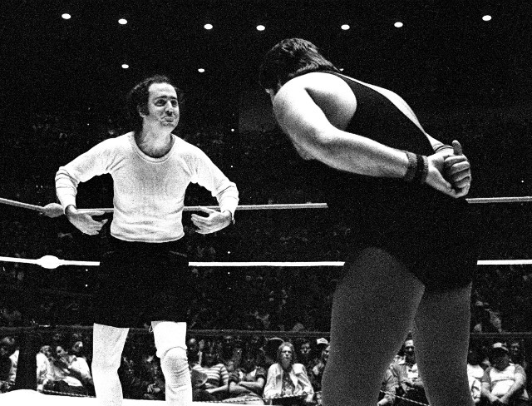
The Great Ruse: The comedic genius who rocked wrestling - CNN.com
Comedian Andy Kaufman taunts Jerry
"The King" Lawler in the Memphis ring in 1982.
By Wayne Drash, CNN

Memphis, Tennessee (CNN) -- Andy Kaufman danced around the wrestling ring in a ridiculous outfit and jumped up and down like an ape. The comedian pointed to his head and mocked the Memphis crowd.
"I'm from Hollywood. I have brains!" he declared. Fans pelted him with Dixie cups.
On this April night 30 years ago, Kaufman worked fans inside the stadium into a frenzy. The coliseum was crammed with the rowdiest characters Memphis had to offer.
Kaufman, the comedic genius with wiry hair and bulging eyes who pushed the envelope of humor. And the whole wrestling episode -- inside the ring and out -- was performance art at its peak. For Kaufman, the fact that so few people caught on made it all the better.
"The reason he's still remembered is he took that idea of being a despicable bad guy and he took it to a whole new level," says Bob Thompson, a professor of pop culture at Syracuse University.
"His badness came not from wanting to take over the world; his badness came from being just so irritating. This was a character, probably more than any I can think of in American popular culture history, that within seconds of hearing him open his mouth, you really wanted to hit him in the face."
Kaufman's wrestling antics would later be immortalized in his infamous expletive-laced tirade on "Late Night with David Letterman," in the R.E.M. song "Man on the Moon" and in the Jim Carrey movie by the same name.
But there in the ring, Kaufman proved to be what everyone in Memphis already knew: The nation's biggest wimp. He'd sent videos showing residents how to use soap, he'd proclaimed Memphis to be the nation's redneck capital.
The way the pencil-necked geek pranced around the ring with his chest swelled, the way he scratched his armpits like a monkey -- well, by God, the arrogant guy needed a whooping.
He'd accepted a challenge from Jerry "The King" Lawler, the city's heroic champion. But when the bell chimed, Kaufman avoided Lawler at all cost, running around the ring as fast as he could as soon the barrel-chested king approached. A frustrated Lawler, playing his part to the hilt, climbed from the ring and grabbed the PA microphone.
"Did you come down here to wrestle or act like an indiot?" Lawler said to wild cheers.
It was the start of one of the greatest ruses of all time, when two men captivated an entire city and puzzled the nation, when Kaufman became the most hated person to ever walk the streets of Memphis.
Their act would get wilder and crazier in the ensuing months, with more matches and more taunts.
And it took years for me to recognize Kaufman for what he was: theatrical genius.
The wrestling community still refuses to recognize it. Thirty years after arguably the most entertaining man ever entered the ring, Kaufman remains shut out. The WWE Hall of Fame won't allow him in.
Kaufman "wasn't just misunderstood by Memphians; he wasn't understood at all," Brown says.
"For Andy to come in and start insulting Jerry and then carrying that over to insulting the entire area, I mean, he was talking about the people of Memphis and this area and putting them down and how they were backwoods. In one interview, he was explaining soap and how they should use it regularly to clean their bodies. I mean, really insulting stuff. And people were just furious."
Did Kaufman infuriate Brown, like the rest of us in the city?
"I wasn't offended by it at all," he chuckles. "I think Andy was a genius."
Russell, now 86, tries to contain his laughter over the phone. No one outside Memphis, he says, could truly understand how despised Kaufman was. Memphians couldn't care less what the rest of the world thought of the performer.
Kaufman’s act did work it was Genius.
CNN's Todd Leopold contributed to this story.

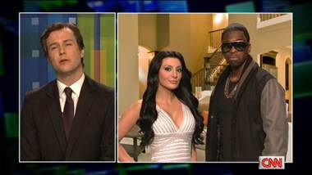
'SNL' Spoofs Coverage of Trayvon Martin Case
http://theclicker.today.msnbc.msn.com/_news/2012/04/15/11209979-snl-spoofs-coverage-of-trayvon-martin-case?lite

By Courtney Garcia, TODAY.com contributor

"Saturday Night Live" took jabs at Piers Morgan, Kim Kardashian, Kanye West and “Game of Thrones" Saturday night, but it was cast member Jay Pharaoh rather than host Josh Brolin who earned the most buzz.

In a controversial skit, cast member Taran Killam reprised his role as news commentator Morgan, and discussed the controversial Trayvon Martin case with a slew of famous figures, including Ozzie Guillen (played by Brolin), West (played by Pharoah), and Kim Kardashian, played by Nasim Pedrad.

The sketch had viewers torn. Many posted angry remarks saying tackling the Martin case crossed the line. Others enjoyed the spoof of West and Kardashian, as well as the take on over-sensationalized media.

And a certain talk-show host himself now wants to get in the game.

Tweeted the real-life Piers Morgan, “I think it's time I hosted #SNL -- they're using me every week for ratings anyway. May as well get paid for it... Lorne?”

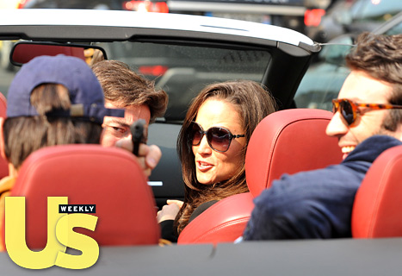
http://www.usmagazine.com/celebrity-news/news/see-pippa-middletons-shocking-gun-pics-2012184
Adapted from US magazine.

Pippa Middleton’s Fake Gun Incident
Almost exactly a year after her sister Kate Middleton's royal wedding, Pippa Middleton is stealing the scene again -- but it's nothing as light-hearted as flirty chats with Prince Harry or a derriere-enhancing bridesmaids' dress.
After partying at a raucous, raunchy bash in Paris until 5 a.m., the socialite, 28, took a spin with three pals in a convertible on Saturday when photographers snapped the foursome -- and, in a bizarre turn of events, the driver of the car took out what appeared to be a semi-automatic pistol and aimed it at the photographer. Sitting in the passenger seat, Middleton laughed.

Nobody's laughing now. As revealed in the new Us Weekly, Middleton will be questioned by French authorities about the gun-waving incident and faces nearly $6000 in fines and even jail time if convicted.
The royal in-laws are not pleased. "This is embarrassing for them," a royal source says. Including big sister Duchess Kate, 30. Her sibling's surprising photo "has put Kate in a very difficult position," the source adds.

The mystery man pointing the gun in question, meanwhile, has finally been identified: He's Romain Rabillard, a 36-year-old French attorney, who ironically represents German firearms manufacturer Heckler & Koch. The single Rabillard parties with a crowd of chic Parisians, including wealthy clothing designer Viscount Arthur de Soultrait -- Middleton's pal, whose wild 30th birthday bash she attended Friday evening.

