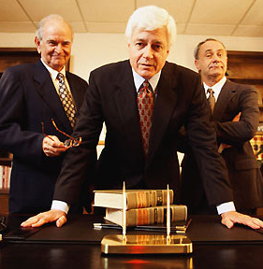

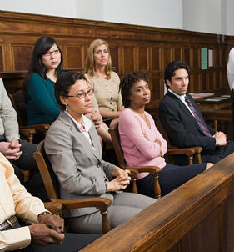
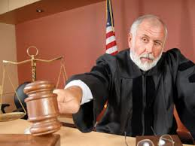
4. The Prosecutor has the opportunity to give a REBUTTAL to take apart the defense, point by point.
2. The Defense attorney makes a COUNTERCLAIM that the crime was not committed by the accused
Or a QUALIFICATION to show that the crime did not happen as the prosecutor claims.
3. The Jury (the audience) hears EVIDENCE from both sides and makes a decision.
1. A Prosecutor makes a CLAIM that someone has done something wrong.
5. The Judge listens to the jury’s decision and, in support of the WARRANT that some acts are unacceptable in our society, decides on a punishment.
Elements of Argument:
They’re like a Court Case

